|  |
| --- |
| Circle Language Spec: Parameters |

## Required & Optional in a Diagram

*Optional* is the default behavior. *Required* is an extra rule imposed. Required is expressed by drawing half a shape at the end of a connector. It should be half of what has to be connected to it. Most of the times it will be half a circle:



For command objects it is half a square:

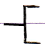

And when a command needs to be executed it is about 5/8th of a diamond:

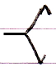

It is not half a diamond because that already symbolizes the Protected access modifier, which is half a cross:

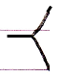

For system commands that require the command call connector notation, also the 5/8th of a diamond is shown when a call is required:

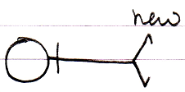

The ‘half a shape’ will also get a line type adapted to the role the required object will get. If the connector specifies that it gets a class role, the half-shape will be drawn with a dashed line.

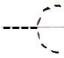

Below you will find examples of *required* connectors. Not every possible connector is shown, but enough to cover the notation.

|  |  |  |
| --- | --- | --- |
|  |  |  |
| Public Required Object Set | Protected Required Object Set | Public Required Object Get |
|  |  |  |
|  |  |  |
| Private Required Object Set | Friend Required Object Set | Private Required Object Get |
|  |  |  |
|  |  |  |
| Protected Required  Object Get | Friend Required Object Get | Public Required Class Set |
|  |  |  |
|  |  |  |
| Public Required Use As Class | Private Required Class Set | Friend Required Value Set |
|  |  |  |
|  |  |  |
| Public Required Clone (2) Get | Public Required New | *(as opposed to)*  Public New |
|  |  |  |
|  |  |  |
| Friend Required Execute | Public Required Object Get | Public Required Use As Class |
|  |  |  |
|  |  |  |
| Public Required Use As Class  (might be a better notation, since it is more likely to be used for plain command calls) |  |  |